**CLOUD COMPUTING NOTES UNIT IV**

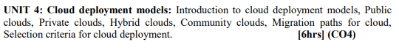

# Cloud Deployment Model

Since cloud technology provides many benefits to users, these benefits should be classified based on the needs of the users. The cloud deployment model represents the exact category of cloud environment based on proprietorship, size, and access and also describes the nature and purpose of the cloud. Most organizations implement cloud infrastructure to minimize capital expenditure & regulate operating costs.

## THE NIST MODEL

The National Institute of Standards and Technology (NIST) is an agency under the scope of the US Department of Commerce, which is responsible for expounding & defining standards in Science and Technology. The Computer Security Division of NISD has provided a formal definition of Cloud computing. The US government is a major consumer of computer technology and one of the major cloud computing network users. According to the NIST working definition of cloud, the deployment model is one of the two categories of the model illustrated by NIST. The NIST model doesn't require cloud technology to use virtualization to share resources. Cloud support multi-tenancy; multi-tenancy is the concept of sharing of resources among two or more clients. The latest NIST model of cloud computing requires virtualization and utilizes the concept of multi-tenancy.

As cloud computing, we have to approach a set of interactive components, such as service-oriented architecture; users can expect that future versions of the NIST model may also include more features.

## Explaining the Deployment Model

To know which deployment model matches your need and desire, it is essential for users and learners to understand the four subcategories of the deployment model.

These are:

* [Public Cloud Model](https://www.w3schools.in/deployment-models-in-cloud-computing/public-cloud-model)
* [Private Cloud Model](https://www.w3schools.in/deployment-models-in-cloud-computing/private-cloud-model)
* [Hybrid Cloud Model](https://www.w3schools.in/deployment-models-in-cloud-computing/hybrid-cloud-model)
* [Community Cloud Model](https://www.w3schools.in/deployment-models-in-cloud-computing/community-cloud-model)

## Public Cloud

Public Cloud is a type of cloud hosting that easily allows the accessibility of systems & its services to its clients/users. Some examples of companies that provide public cloud facilities are IBM, Google, Amazon, Microsoft, etc. This cloud service is open for use. This type of cloud computing is a true specimen of cloud hosting, where the service providers render services to various clients. From the technical point of view, there is the least difference between private clouds and public clouds along with the structural design. Only the security level depends based on the service providers and the type of cloud clients use. The public cloud is better suited for business purposes for managing the load. This type of cloud is economical due to the decrease in capital overheads.

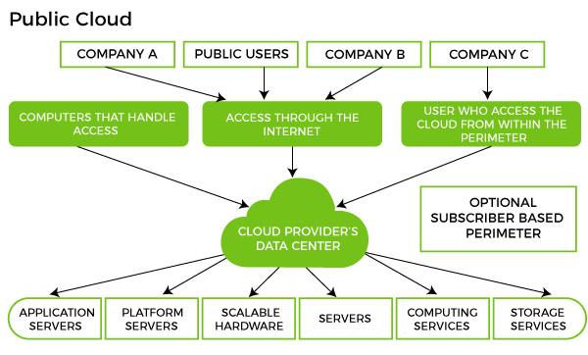

Benefits of Public Cloud

* Minimal Investment - As a pay-per-use service, there is no large upfront cost and is ideal for businesses who need quick access to resources
* No Hardware Setup - The cloud service providers fully fund the entire Infrastructure
* No Infrastructure Management - This does not require an in-house team to utilize the public cloud.

Limitations of Public Cloud

* Data Security and Privacy Concerns - Since it is accessible to all, it does not fully protect against cyber-attacks and could lead to vulnerabilities.
* Reliability Issues - Since the same server network is open to a wide range of users, it can lead to malfunction and outages
* Service/License Limitation - While there are many resources you can exchange with tenants, there is a usage cap.

## Private Cloud

Private Cloud is also termed as 'Internal Cloud', which allows the accessibility of systems and services within a specific boundary or organization. The cloud platform is implemented in a cloud-based secure environment guarded by advanced firewalls under the surveillance of the IT department that belongs to a particular organization. Private clouds permit only authorized users, providing the organizations greater control over data and its security. Business organizations that have dynamic, critical, secured, management demand-based requirements should adopt Private Cloud.

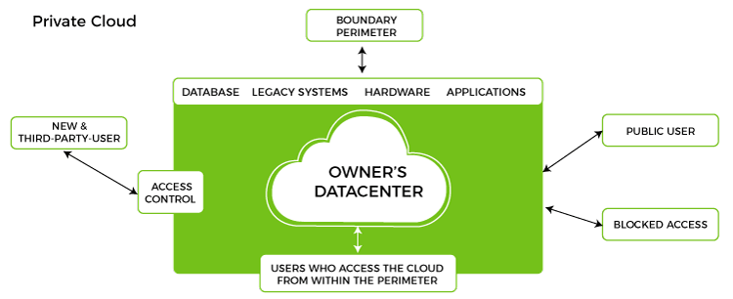

Benefits of Private Cloud

* Data Privacy - It is ideal for storing corporate data where only authorized personnel gets access
* Security - Segmentation of resources within the same Infrastructure can help with better access and higher levels of security.
* Supports Legacy Systems - This model supports legacy systems that cannot access the public cloud.

Limitations of Private Cloud

* Higher Cost - With the benefits you get, the investment will also be larger than the public cloud. Here, you will pay for software, hardware, and resources for staff and training.
* Fixed Scalability - The hardware you choose will accordingly help you scale in a certain direction
* High Maintenance - Since it is managed in-house, the maintenance costs also increase.

## Hybrid Cloud

Hybrid Cloud is another cloud computing type, which is integrated, i.e., it can be a combination of two or more cloud servers, i.e., private, public, or community combined as one architecture, but remain individual entities. Non-critical tasks such as development and test workloads can be done using the public cloud. In contrast, critical tasks that are sensitive such as organization data handling, are done using a private cloud. Benefits of both deployment models, as well as a community deployment model, are possible in a hybrid cloud hosting. It can cross isolation and overcome boundaries by the provider; hence, it cannot be categorized into any of the three deployments - public, private, or community cloud.

Let's understand the hybrid model better. A company with critical data will prefer storing on a private cloud, while less sensitive data can be stored on a public cloud. The hybrid cloud is also frequently used for 'cloud bursting'. It means, supposes an organization runs an application on-premises, but due to heavy load, it can burst into the public cloud.

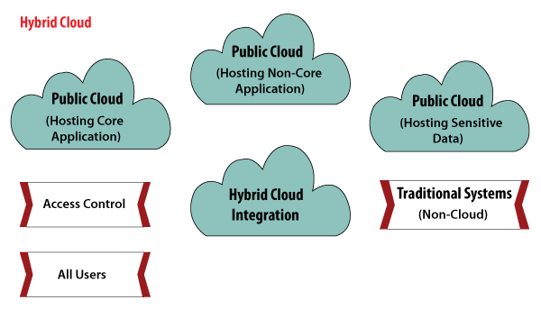

Benefits of Hybrid Cloud

* Cost-Effectiveness - The overall cost of a hybrid solution decreases since it majorly uses the public cloud to store data.
* Security - Since data is properly segmented, the chances of data theft from attackers are significantly reduced.
* Flexibility - With higher levels of flexibility, businesses can create custom solutions that fit their exact requirements

Limitations of Hybrid Cloud

* Complexity - It is complex setting up a hybrid cloud since it needs to integrate two or more cloud architectures
* Specific Use Case - This model makes more sense for organizations that have multiple use cases or need to separate critical and sensitive data

## Community Cloud

Community Cloud is another type of cloud computing in which the cloud setup is shared manually among different organizations that belong to the same community or area. An example of such a community is where organizations/firms are there, along with the financial institutions/banks. A multi-tenant setup developed using cloud among different organizations that belong to a particular community or group having similar computing concerns.

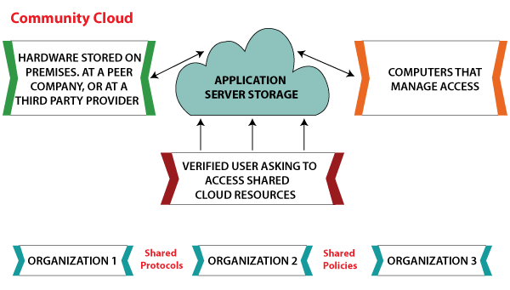

Benefits of Community Cloud

* Smaller Investment - A community cloud is much cheaper than the private & public cloud and provides great performance
* Setup Benefits - The protocols and configuration of a community cloud must align with industry standards, allowing customers to work much more efficiently.

Limitations of Community Cloud

* Shared Resources - Due to restricted bandwidth and storage capacity, community resources often pose challenges.
* Not as Popular - Since this is a recently introduced model, it is not that popular or available across industries

## A Comparative Analysis of Cloud Deployment Models

With the below table, we have attempted to analyze the key models with an overview of what each one can do for you:

| **Important Factors to Consider** | **Public** | **Private** | **Community** | **Hybrid** |
| --- | --- | --- | --- | --- |
| Setup and ease of use | Easy | Requires professional IT Team | Requires professional IT Team | Requires professional IT Team |
| Data Security and Privacy | Low | High | Very High | High |
| Scalability and flexibility | High | High | Fixed requirements | High |
| Cost-Effectiveness | Most affordable | Most expensive | Cost is distributed among members | Cheaper than private but more expensive than public |

## Selection Criteria for Cloud Deployment Models

There is no one-size-fits-all approach to picking a cloud deployment model. Instead, organizations must select a model based on workload-by-workload. Start with assessing your needs and consider what type of support your application requires. Here are a few factors you can consider before making the call:

* Ease of Use - How savvy and trained are your resources? Do you have the time and the money to put them through training?
* Cost - How much are you willing to spend on a deployment model? How much can you pay upfront on subscription, maintenance, updates, and more?
* Scalability - What is your current activity status? Does your system run into high demand?
* Compliance - Are there any specific laws or regulations in your country that can impact the implementation? What are the industry standards that you must adhere to?
* Privacy - Have you set strict privacy rules for the data you gather?

Each cloud deployment model has a unique offering and can immensely add value to your business. For small to medium-sized businesses, a public cloud is an ideal model to start with. And as your requirements change, you can switch over to a different deployment model. An effective strategy can be designed depending on your needs using the cloud mentioned above deployment models.

# MIGRATING INTO THE CLOUD

## Why Migrate?

* There are economic and business reasons why an enterprise application can be migrated into the cloud, and there are also a number of technological reasons.
* Initiatives in adoption of cloud technologies in the enterprise,
* resulting in integration of enterprise applications running off the captive data centers with the new ones that have been developed on the cloud.

Migration can happen at one of the five levels of

* application,
* code,
* design,
* architecture,
* usage

The migration of an enterprise application is best captured by the following

***P→P’C + P’1→P’OFC + P’1***

where

***P*** is the application before migration running in captive data center,

***P’C*** is the application part after migration either into a (hybrid) cloud,

***P’1***is the part of application being run in the captive local data center, and

***P’OFC***  is the application part optimized for cloud

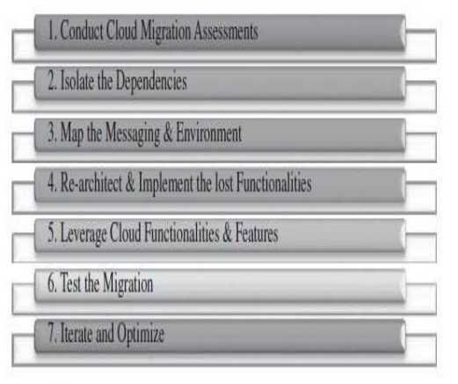

Fig : The seven step model of Migration into the Cloud (infosys)

### Iterative Step

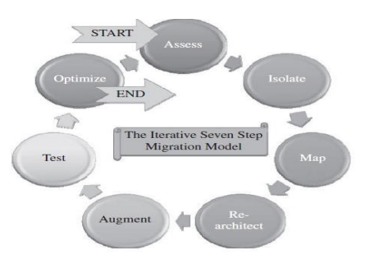

Fig : The iterative seven-step model of migration into the cloud (infosys)

## Migration Risks and Mitigation

* The biggest challenge to any cloud migration project is how effectively the migration risks are identified and mitigated.
* Migration risks for migrating into the cloud fall under two broad categories:

#### The general migration risks

* the security-related migration risks
* several issues identifying all possible production level deviants:
  + the business continuity and disaster recovery in the world of cloud computing service;
  + the compliance with standards and governance issues; the IP and licensing issues;
  + the quality of service (QoS) parameters as well as the corresponding SLAs committed to;
  + the ownership, transfer, and storage of data in the application;
  + the portability and interoperability issues which could help mitigate potentialvendor lock-ins;

# 

# VIRTUAL MACHINES PROVISIONING

Typical life cycle of VM and its major possible states of operation, which make the management and automation of VMs in virtual and cloud environments easier

## Process:

## Steps to Provision VM.

Here, we describe the common and normal steps of provisioning a virtual server:

* Firstly, you need to select a server from a pool of available servers (physical servers with enough capacity) along with the appropriate OS template you need to provision the virtual machine.
* Secondly, you need to load the appropriate software (operating system you selected in the previous step, device drivers, middleware, and the needed applications for the service required).
* Thirdly, you need to customize and configure the machine (e.g., IP address, Gateway) to configure an associated network and storage resources.
* Finally, the virtual server is ready to start with its newly loaded software

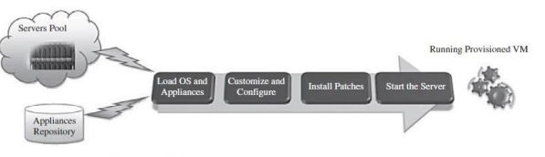

Fig: Virtual Machine Provisioning Process

## VIRTUAL MACHINE MIGRATION SERVICES

#### Migration service,

* in the context of virtual machines, is the process of moving a virtual machine from one host server or storage location to another
* There are different techniques of VM migration,
* hot/life migration,
* cold/regular migration, and
* live storage migration of a virtual machine

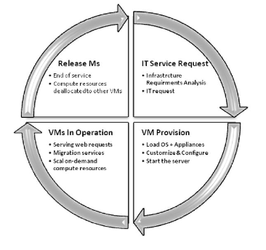

Fig: Virtual Machine lifeCycle

#### 

#### VM Migration, SLA and On-Demand Computing:

* virtual machines’ migration plays an important role in data centers
* once it has been detected that a particular VM is consuming more than its fair share of resources at the expense of other VMs on the same host,it will be eligible, for this machine, to either be moved to another underutilized host or assign more resources for it
* There should be an integration between virtualization’s management tools (with its migrations and performance’s monitoring capabilities), and SLA’s management tools to achieve balance in resources by migrating and monitoring the workloads, and accordingly, meeting the SLA

#### Migration of Virtual Machines to Alternate Platforms

* Advantages of having facility in data center’s technologies is
  + to have the ability to migrate virtual machines from one platform to another
  + For example, the VMware converter that handles migrations between ESX hosts;
  + the VMware server; and the VMware workstation.
  + The VMware converter can also import from other virtualization platforms, such as Microsoft virtual server machines

### Deployment Scenario

* ConVirt deployment consists of at least one ConVirt workstation
* whereConVirt is installed and ran, which provides the main console for managing the VM life cycle, managing images, provisioning new VMs, monitoring machine resources, and so on.
* There are two essential deployment scenarios for ConVirt:
* A, basic configuration in which the Xen or KVM virtualization platform is on the local machine, where ConVirt is already installed; B,
* An advanced configuration in which the Xen or KVM is on one or more remote servers.

### VMware Vmotion.

* This allows users to

1. automatically optimize and allocate an entire pool of resources for maximum hardware utilization, flexibility, and availability and
2. perform hardware’s maintenance without scheduled downtime along with migrating virtual machines away from failing or underperforming servers

### Citrix XenServerXenMotion.

* This is a nice feature of the Citrix XenServer product, inherited from the Xen live migrate utility, which provides the IT administrator with the facility to move a running VM from one XenServer to another in the same pool without interrupting the service

### Regular/Cold Migration.

Cold migration is the migration of a powered-off virtual machine.

Main differences between live migration and cold migration are that

1. live migration needs a shared storage for virtual machines in the server’s pool, but cold migration does not;
2. live migration for a virtual machine between two hosts, there would be certain CPU compatibility checks to be applied; while in cold migration this checks do not apply

* The cold migration process (VMware ) can be summarized as follows:
  + The configuration files, including the NVRAM file (BIOS settings), log files, as well as the disks of the virtual machine, are moved from the source host to the destination host’s associated storage area.
  + The virtual machine is registered with the new host.
  + After the migration is completed, the old version of the virtual machine is deleted from the source host.

### Live Storage Migration of Virtual Machine

* This kind of migration constitutes moving the virtual disks or configuration file of a running virtual machine to a new data store without any interruption in the availability of the virtual machine’s service